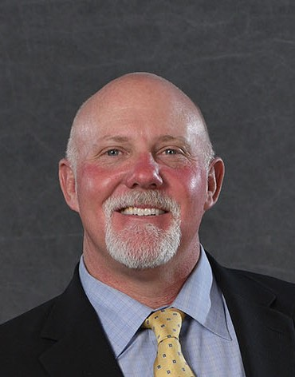
Craig Meis
Retired (Previously Tallgrass Energy)
- Born and raised in Colorado, grew up in Thornton, CO
- Graduated Colorado School of Mines in 1994 with BS in Chemical Engineering and Petroleum Refining
- Married in 1994 to Carrie Bosso of Arvada and have 6 kids between ages of 28 – 14
- Registered Professional Engineer in CO, TX and WY

Started my professional career with a small environmental consulting firm in Denver and within a couple years was hired by an energy client (KN Energy) to relocate to Grand Junction, CO and manage a new environmental field services division. Within a couple years, was also managing the well tending, water hauling, and roustabout divisions of KN Field Services in the Piceance Basin. In 1999, started environmental/engineering consulting company (Cordilleran) based in Grand Junction. Grew the business to serve the Oil and Gas Industry in the Rocky Mountain States and sold to Olsson Associates in 2008 and stayed on with Olsson until 2012. Elected to serve as Mesa County Commissioner from 2005 to 2012 and associated with being a County Commissioner served on many other State, regional and local boards and commissions within that time. When Tallgrass Energy was formed in November of 2012, moved back to Front Range to lead Environmental, Health and Safety programs and compliance for Tallgrass. After much growth and many changes, decided it was time to retire from Tallgrass in August 2021 as VP of Environmental, Health, Safety, Physical Security and Governmental Affairs. Currently serving in an Advisory role with Perenfra, a water infrastructure firm based out of Lafayette, CO.

